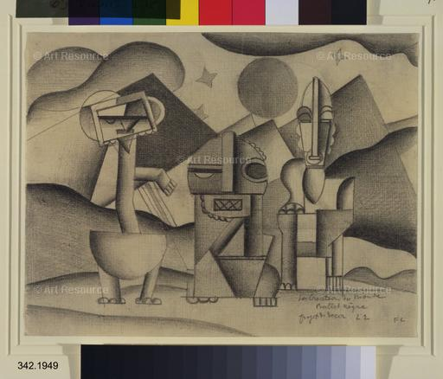

[Leger, Fernand (1881-1955) © ARS, NY](javascript:Matrix3.mbClick=false;void(0);)

*The Creation of the World*, design for the scenery, 1922. Pencil on paper, 8 1/4 x 10 5/8". Gift of John Pratt. (342.1949)

Location: The Museum of Modern Art, New York, NY, U.S.A.

Photo Credit: Digital Image © The Museum of Modern Art/Licensed by SCALA / Art Resource, NY

Image Reference: ART309208

Image size: 4725 X 4037 px